BansilalRamnathAgarwalCharitableTrust’s

VishwakarmaInstituteofTechnology, Pune-37
(AnautonomousInstituteofSavitribaiPhulePuneUniversity)


Department of Multidisciplinary Engineering

Division | AIML-A
Batch | B2
GR-no | 12414334
Rollno | 49
Name | Bhagat Rishikesh Vijay

- Assignment No. 7
- Title - Random Forest Classification and Regression
- Theory

1. Introduction
Random Forest is a supervised machine learning algorithm used for both classification and regression tasks. It is an ensemble learning technique that combines the predictions of multiple Decision Trees to produce a more reliable and stable result.
Instead of relying on a single Decision Tree, Random Forest constructs several trees using different samples of the training dataset and subsets of features. The predictions from these trees are combined to generate the final output.

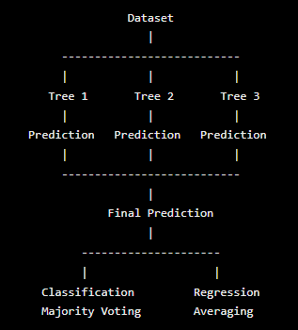

For classification, the final output is determined by majority voting.
For regression, the final output is generally calculated by averaging the predictions of all trees.

2. Random Forest Classification
Random Forest Classification is used when the target variable consists of discrete categories or classes.
Each Decision Tree predicts a class label, and the class receiving the highest number of votes becomes the final prediction.

Example:

Suppose five Decision Trees predict the following classes:
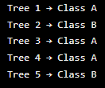

The final prediction is Class A, because it receives three out of five votes.

Random Forest Classification can be applied to problems such as spam detection, fraud detection, and disease classification. It generally does not require feature scaling because Decision Trees use feature-based splitting rather than distance calculations.

3. Random Forest Regression
Random Forest Regression is used when the target variable is a continuous numerical value.
Each Decision Tree produces a numerical prediction. The Random Forest calculates the average of the predictions.
For example:
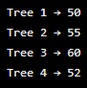
Final prediction:
50+55+60+524 = 54.25 \ (50+55+60+52) (4) = 54.25
Therefore, the predicted value is 54.25.

4. Important Parameters
The performance of a Random Forest model depends on several important hyperparameters.

- n_estimators: Specifies the number of Decision Trees in the forest.
- criterion: Defines the function used to measure the quality of a split. Its available options depend on whether the task is classification or regression.
- max_depth: Specifies the maximum depth allowed for each Decision Tree.
- min_samples_split: Defines the minimum number of samples required to split an internal node.
- random_state: Controls randomness to help produce reproducible results.
- max_features: Specifies the number of features considered when searching for the best split.

Increasing the number of trees can improve the stability of predictions, but it also increases computational and memory requirements.

5. Advantages
- Generally provides better generalization than a single Decision Tree.
- Can be used for both classification and regression.
- Can model non-linear relationships.
- Less prone to overfitting than a single unrestricted Decision Tree.
- Works with many features.
- Provides feature importance information.
- Does not generally require feature scaling.

6. Disadvantages
- More computationally expensive than a single Decision Tree.
- Requires more memory because many trees are stored.
- The complete model is less easy to interpret than one Decision Tree.
- Large forests can increase prediction time.

7. Evaluation Metrics
Classification:
- Accuracy
- Precision
- Recall
- F1-score
- Confusion Matrix
Regression:
- MAE (Mean Absolute Error)
- MSE (Mean Squared Error)
- RMSE (Root Mean Squared Error)
- R² Score

8. Applications
Classification: Fraud detection, medical classification, customer classification, spam detection and image classification.
Regression: House price prediction, sales forecasting, demand prediction, energy consumption and financial prediction.

Conclusion
Random Forest is an ensemble machine learning algorithm that combines multiple Decision Trees to produce a more stable prediction. For classification, it uses majority voting, while for regression, it uses the average of tree predictions. It can handle complex and non-linear relationships and generally provides strong performance without requiring feature scaling.

Classification

Regression

